Azure Networking Homework: NAT Configuration with Private Subnet

Objective
Create an Azure Virtual Network with two subnets (Public and Private).
Configure a Route Table to allow internet access using NAT.
Deploy a Virtual Machine in the private subnet and verify outbound connectivity using Azure Bastion and curl command.

Prerequisites
• Azure account with active subscription
• Access to Azure Portal
• Basic understanding of Azure Virtual Network
• SSH client knowledge
• Existing or newly created Resource Group

Step 1: Create a Resource Group
1. Login to Azure Portal.
2. Search for 'Resource Groups'.
3. Click 'Create'.
4. Enter:
- Resource Group Name
- Region
5. Click 'Review + Create' then 'Create'.

Screenshot:
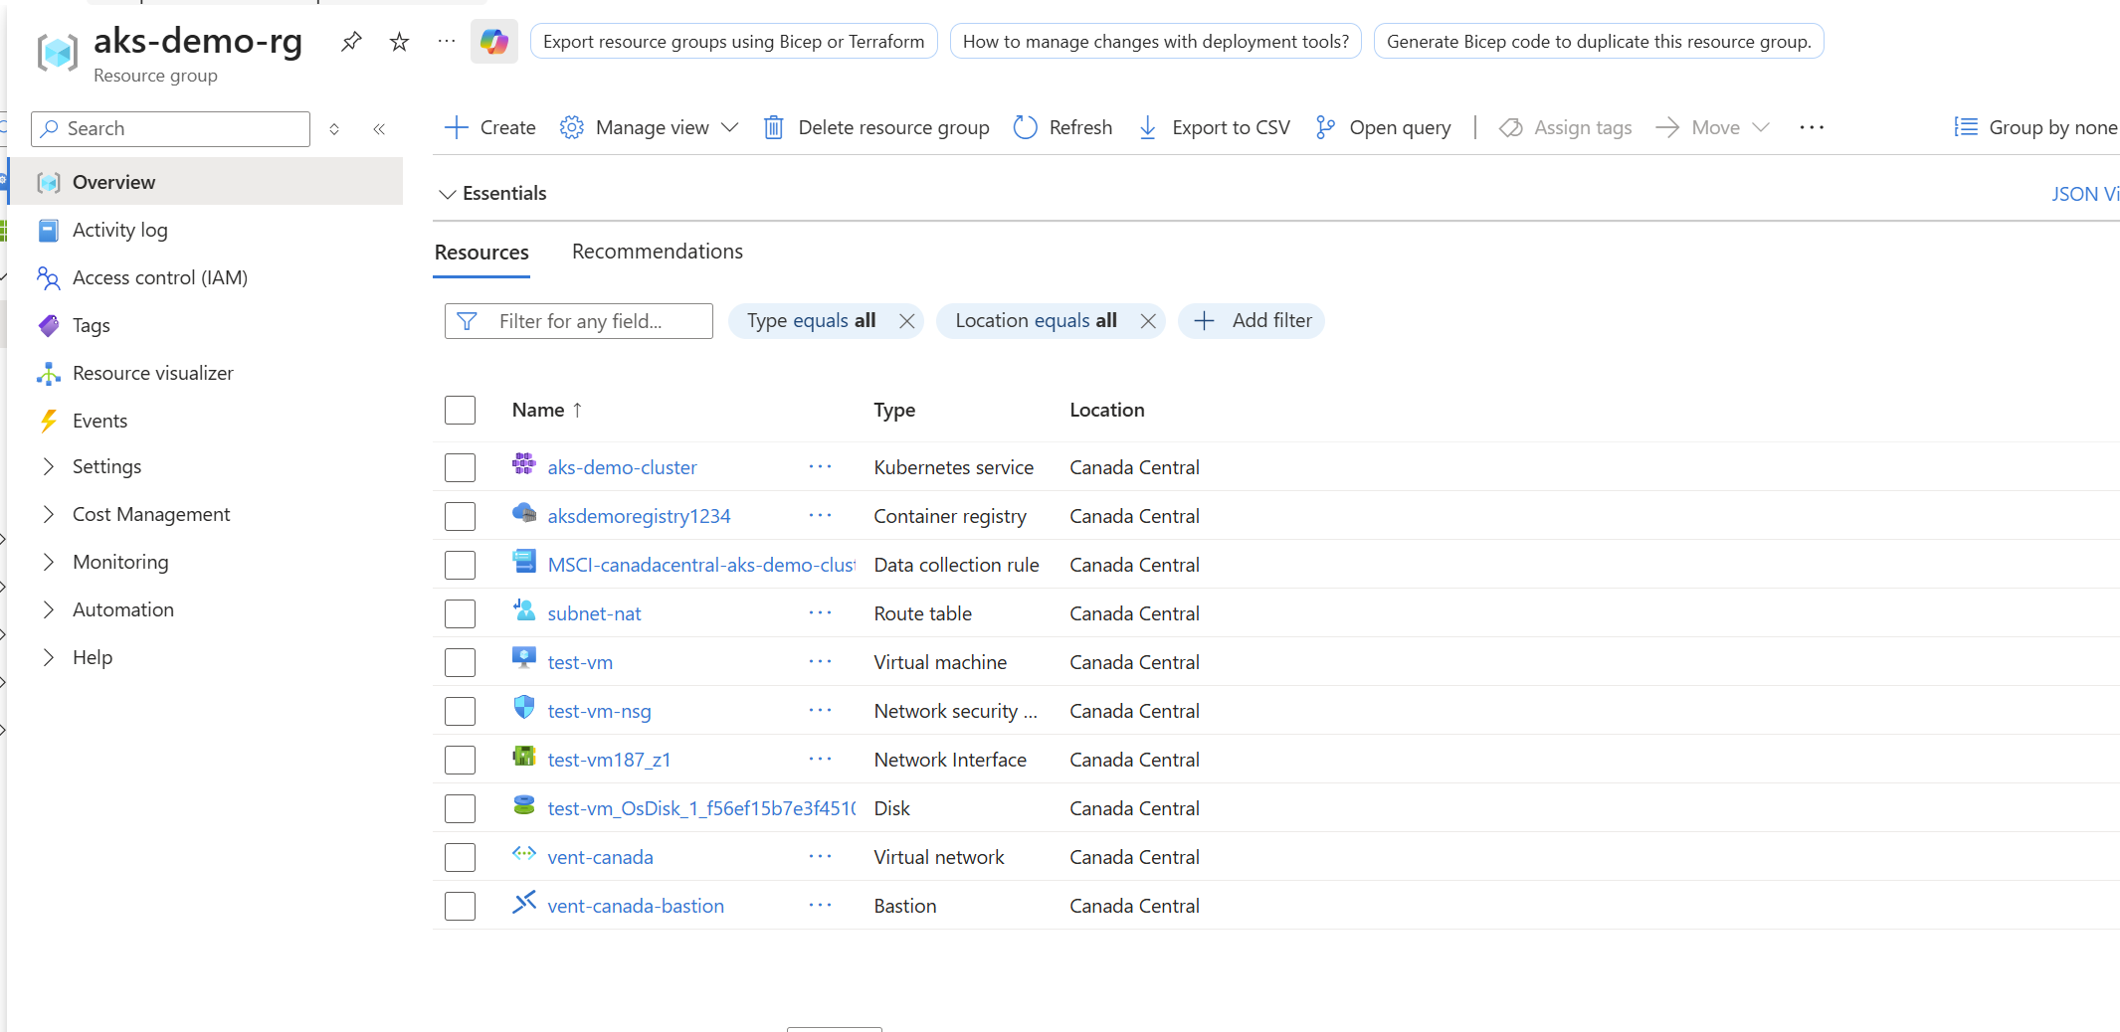

Step 2: Create Virtual Network
1. Go to 'Virtual Networks' in Azure Portal.
2. Click 'Create'.
3. Fill details:
- Resource Group
- Virtual Network Name
- Region
4. Address space example: 10.0.0.0/16
5. Click 'Next'.

Screenshot:
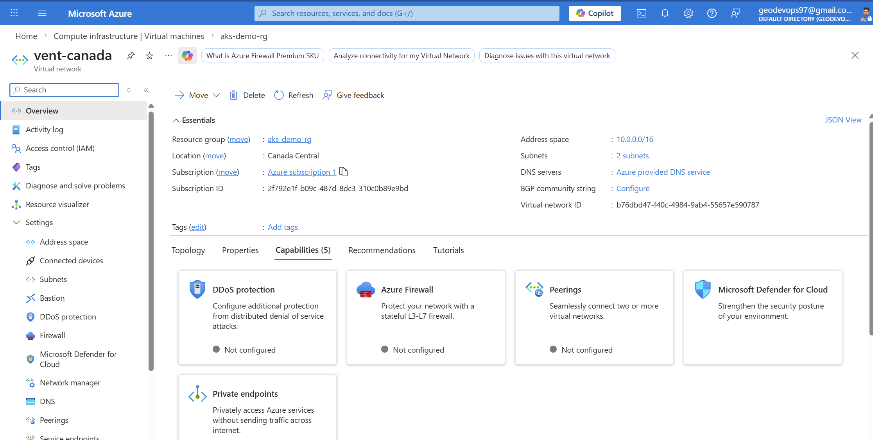

Step 3: Create Two Subnets (Public and Private)
Inside the VNet creation page:

Public Subnet
Name: Subnet1
Address range: 10.0.1.0/24

Private Subnet
Name: Subnet2
Address range: 10.0.2.0/24

Complete creation.
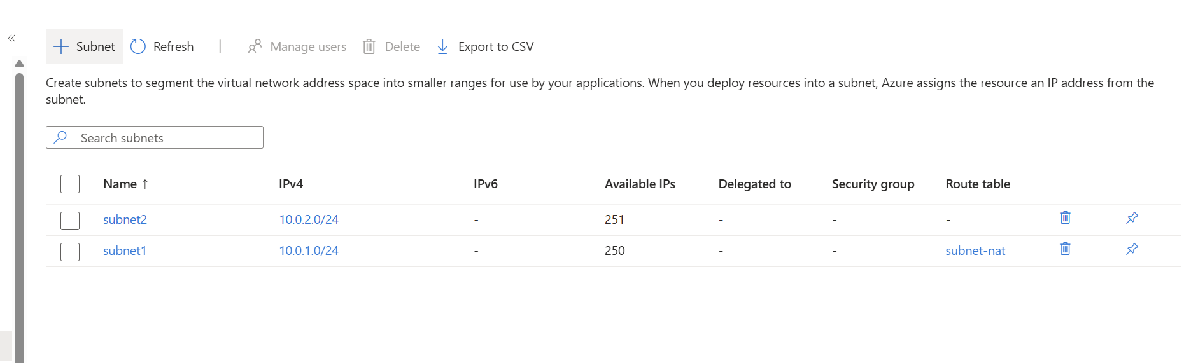
Screenshot:

Step 4: Create a Route Table
1. Search for 'Route Tables'.
2. Click 'Create'.
3. Provide:
- Name: subnet-nat
- Resource Group
- Region
4. Click 'Review + Create'.

Screenshot:
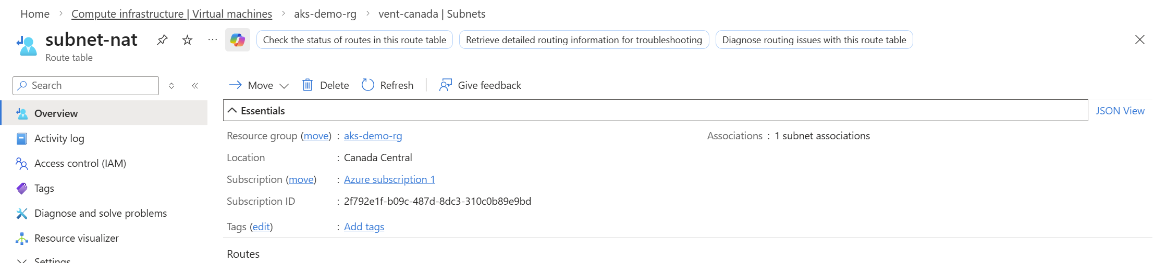

Step 5: Add Route for Internet Access
1. Open the Route Table.
2. Click 'Routes'.
3. Click 'Add'.

Configure:
Name: First Table
Address Prefix: 0.0.0.0/16
Next Hop Type: Internet

Save the route.

Screenshot:
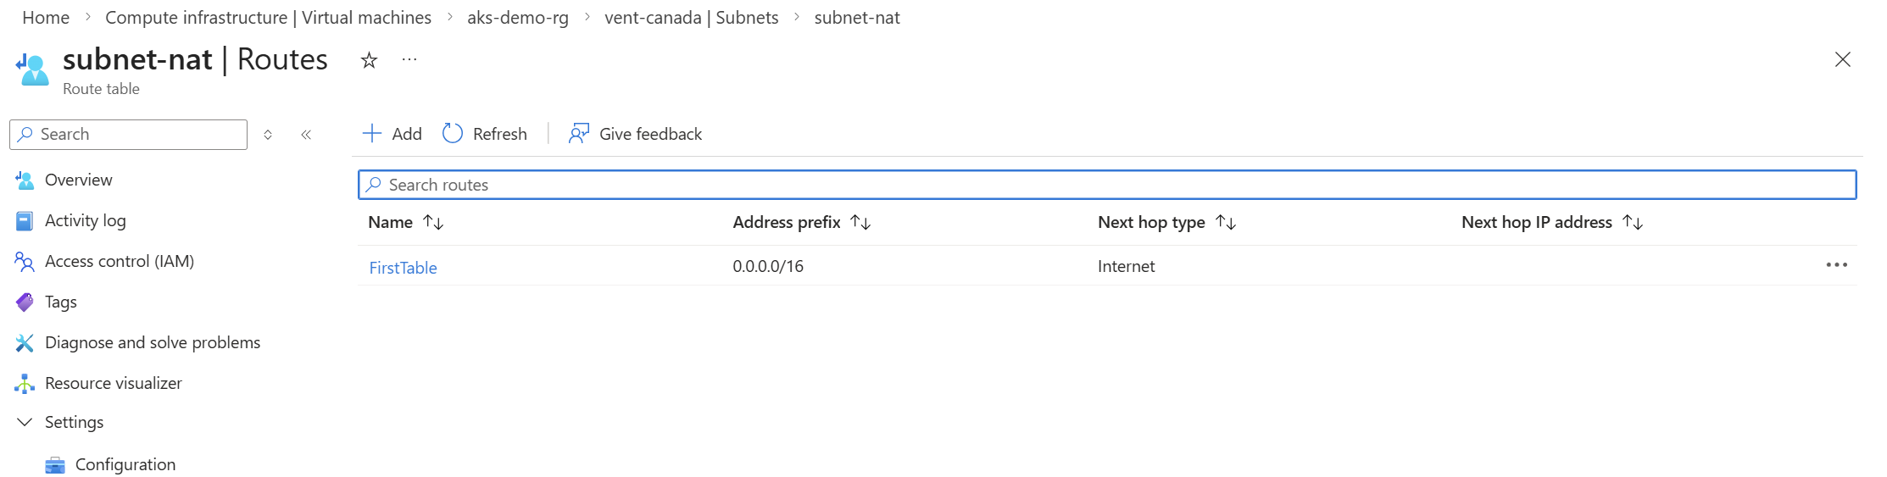

Step 6: Associate Route Table with Private Subnet
1. Open the Route Table.
2. Select 'Subnets'.
3. Click 'Associate'.
4. Select the Virtual Network.
5. Choose the Subnet1.

Screenshot:
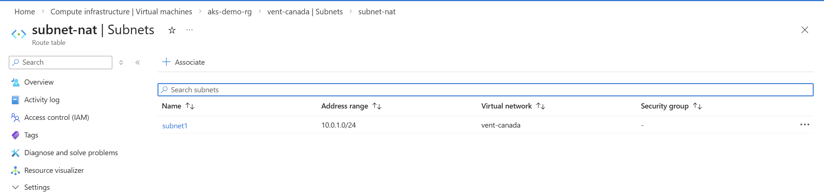

Step 7: Create a Virtual Machine in Private Subnet
1. Go to 'Virtual Machines'.
2. Click 'Create VM'.
3. Configure:
- Resource Group
- VM Name
- Image (Ubuntu recommended)
- Size

Networking:
Select the previously created VNet.
Choose 'Subnet1'.

Create the VM.

Screenshot:
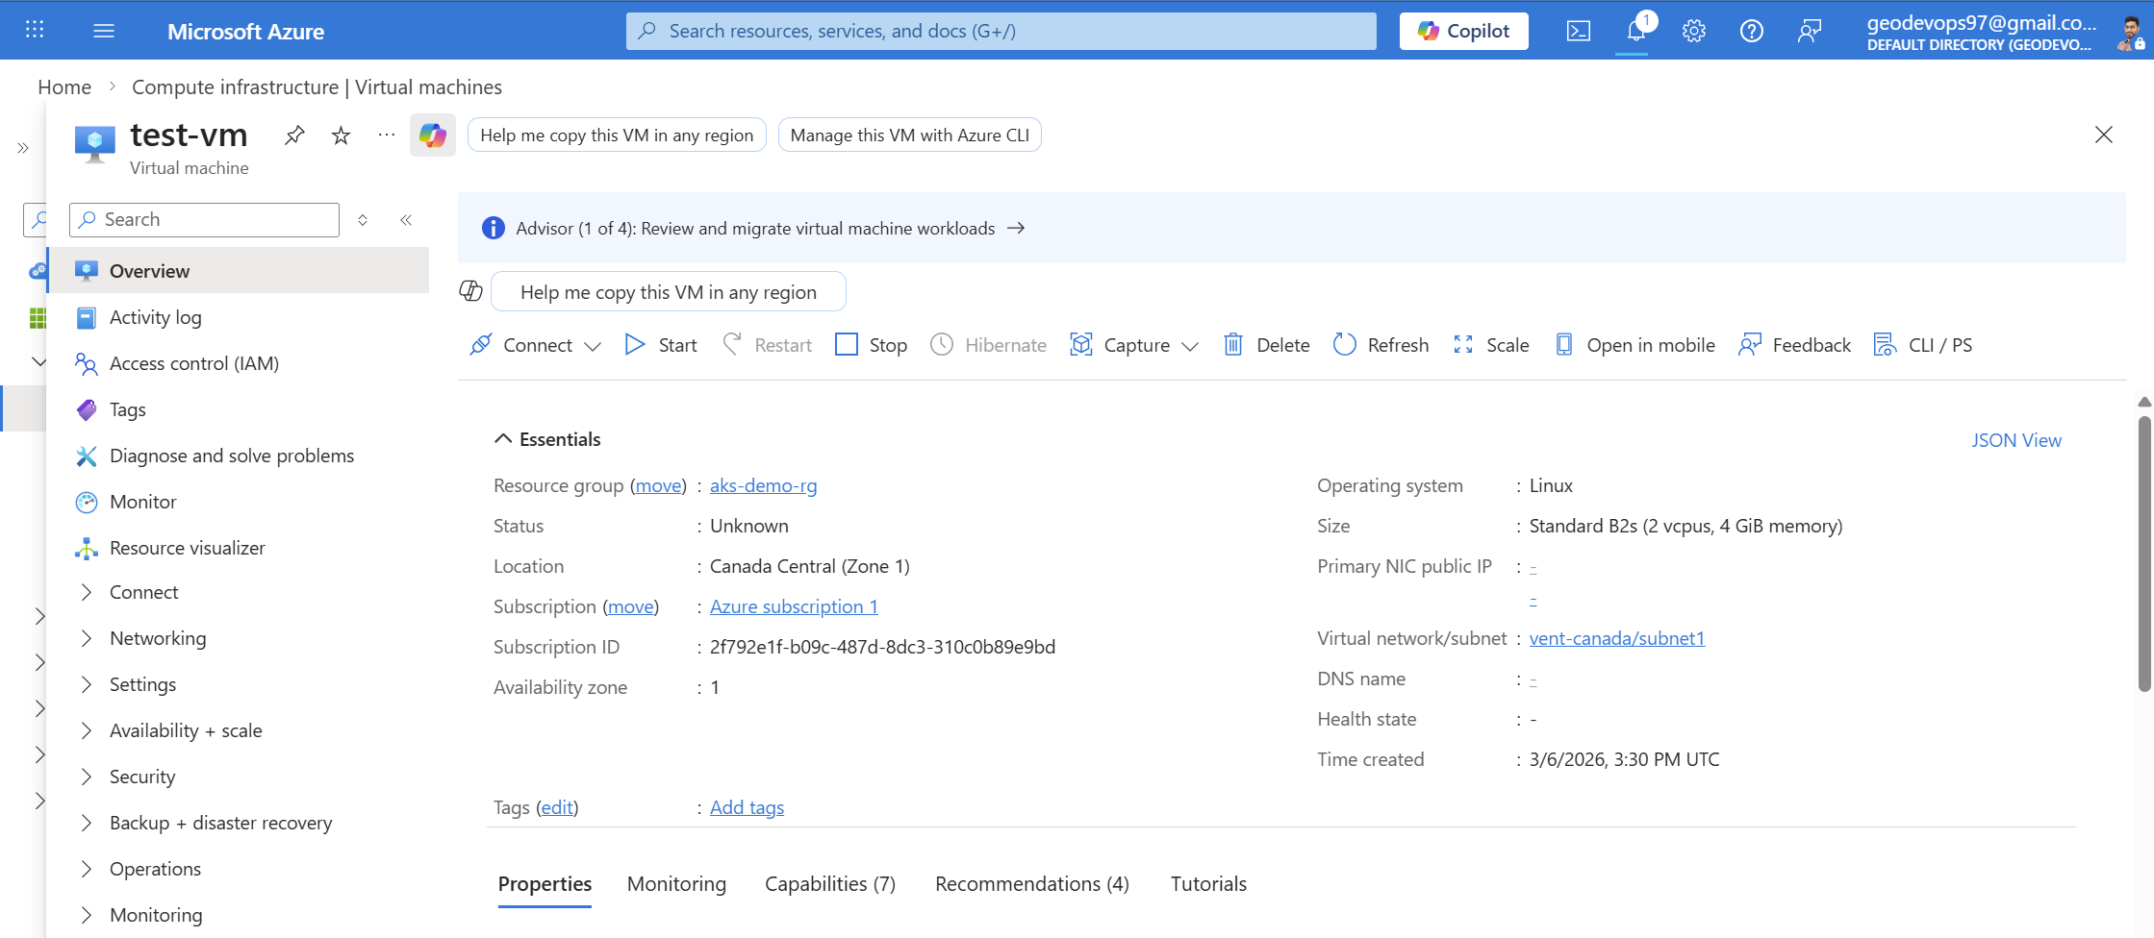

Step 8: Connect to VM using Bastion
1. Open the Virtual Machine.
2. Click 'Connect'.
3. Select 'Bastion'.
4. Enter username and password.
5. Open SSH session in browser.

Screenshot:
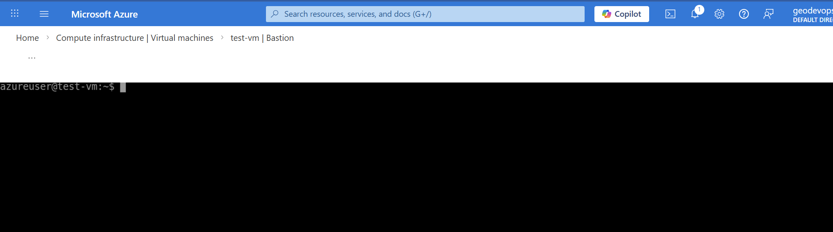

Step 9: Test Internet Connectivity using curl
Inside the VM terminal run:

curl https://www.google.com

If NAT and routing works correctly, HTML response will appear.

Screenshot:
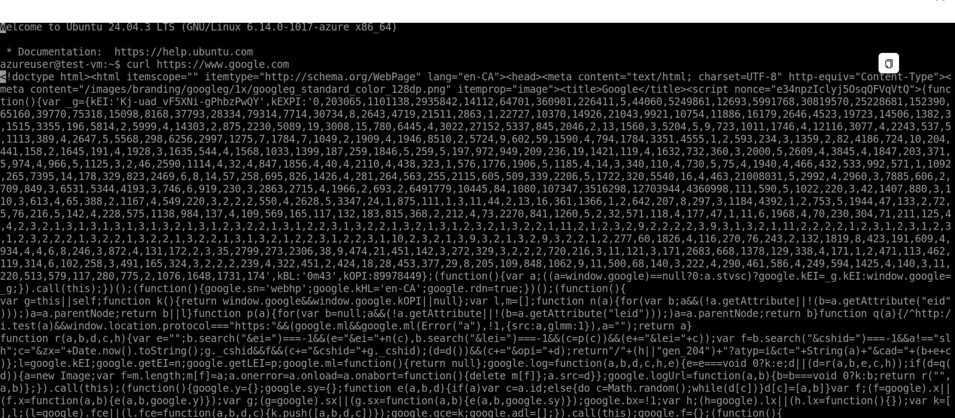

Conclusion
In this lab we successfully:
• Created a Virtual Network with Public and Private Subnets
• Configured a Route Table
• Associated the Route Table with Private Subnet
• Deployed a Virtual Machine in the Private Subnet
• Used Azure Bastion to securely connect
• Verified internet access using curl command

